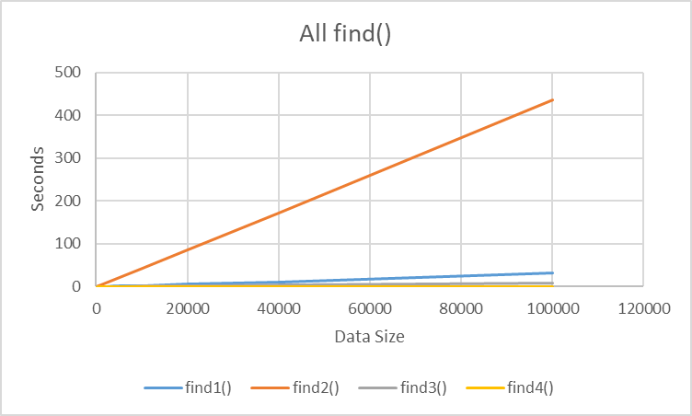

All data points listed

find1() = **O(n)**

because linear search list

find2() = **O(n^2(log(n))^2)**

Copy created: O(n)

Sort: O(nlog(n))

Binary search: O(log(n))

O(n) * O(nlog(n)) * O(log(n))

Result: O(n^2(log(n))^2)

find3() = **O(n)**

since find3() uses a built-in function

find4() = **O(log(n))**

because find4() is a binary search in a sorted list